Ansible

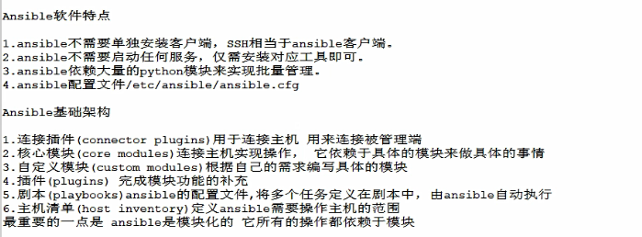

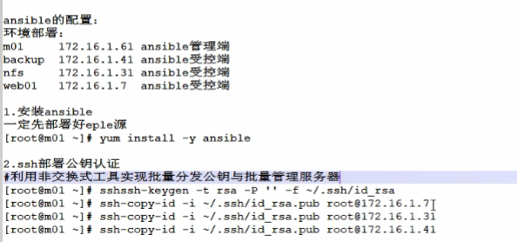

|  |
| --- |
| ssh-keygen -t rsa -P '' -f ~/.ssh/id_rsa  ssh-copy-id -i ~/.ssh/id_rsa.pub [root@192.168.91.12 #backup](mailto:root@192.168.91.12)  ssh-copy-id -i ~/.ssh/id_rsa.pub [root@192.168.91.13](mailto:root@192.168.91.13) #nfs  ssh-copy-id -i ~/.ssh/id_rsa.pub [root@192.168.91.14](mailto:root@192.168.91.14) #web |

配置ansible主机清单

|  |
| --- |
| [root@localhost ~ 09:55:22&&13]#vim /etc/ansible/hosts  [oldboy]  192.168.91.12  192.168.91.13  192.168.91.14 |

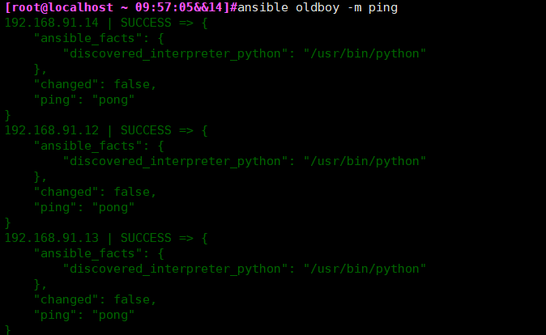

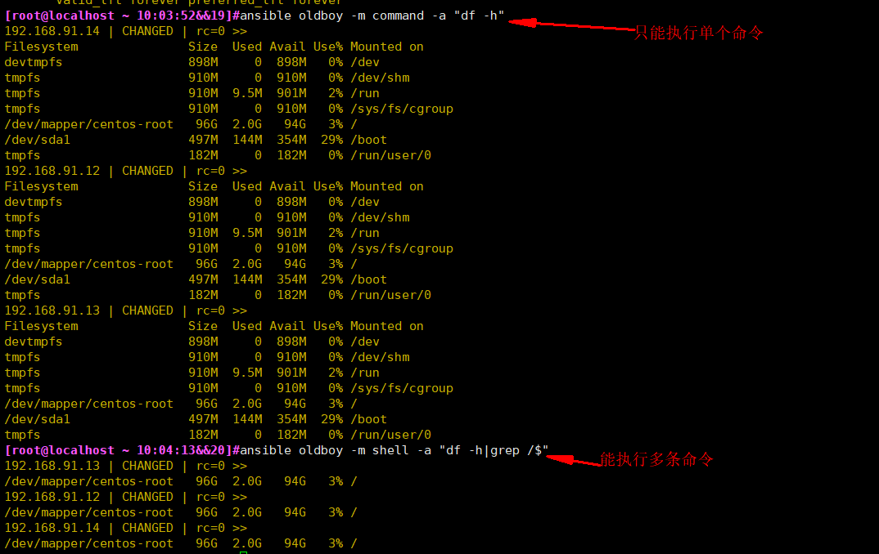

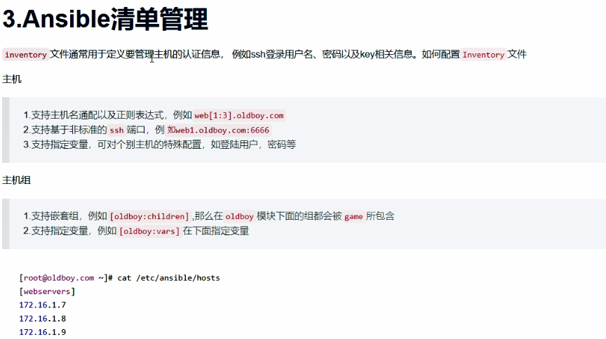

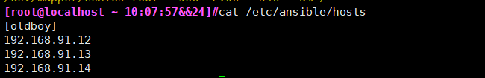

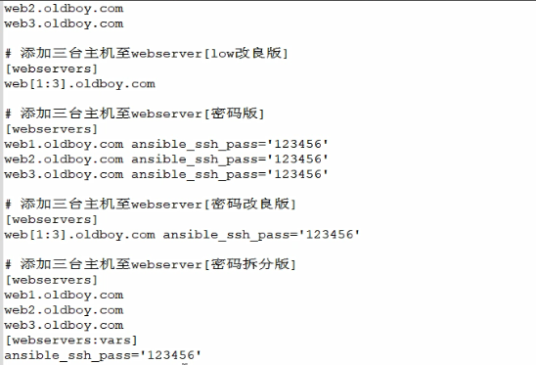

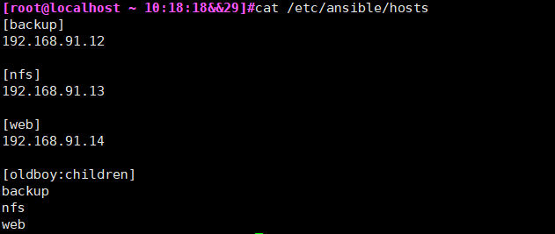

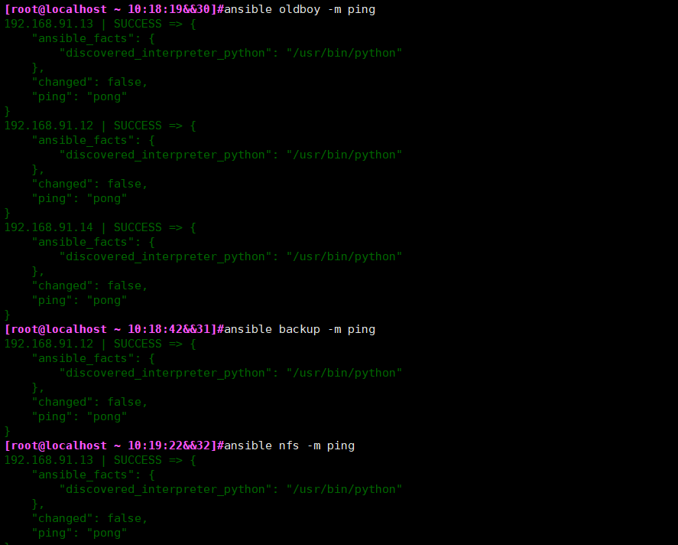

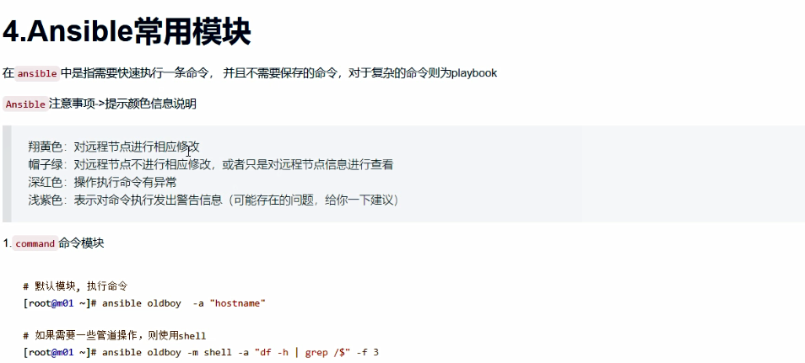



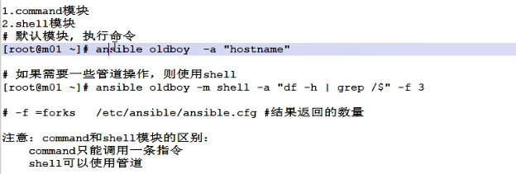

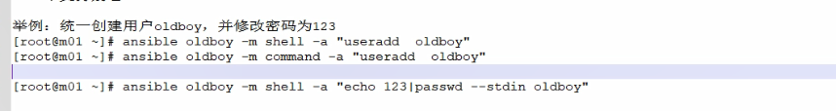

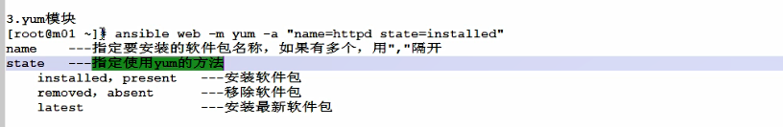

|  |
| --- |
| [root@localhost ~ 10:27:02&&34]#ansible web -m yum -a "name=httpd state=installed" |

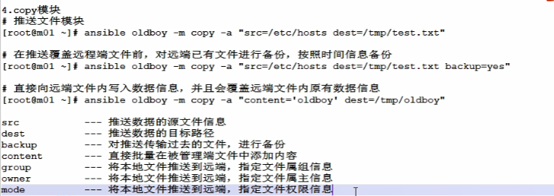

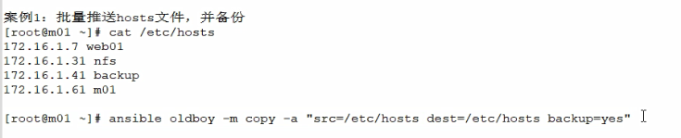

|  |
| --- |
| [root@localhost ~ 10:36:15&&36]#ansible oldboy -m copy -a "src=/etc/hosts dest=/etc/hosts backup=yes" |

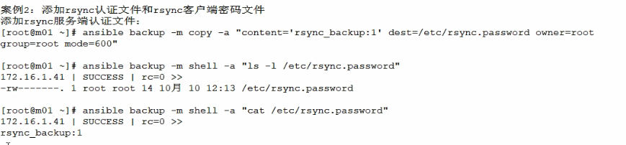

|  |
| --- |
| [root@localhost ~ 10:37:08&&37]#ansible backup -m copy -a "content='rsync_backup:1' dest=/etc/rsync.passwd owner=root group=root mode=600" |

|  |
| --- |
| [root@localhost ~ 10:42:25&&39]#ansible backup -m shell -a "ls -l /etc/rsync.passwd"  [root@localhost ~ 10:42:44&&40]#ansible backup -m shell -a "cat /etc/rsync.passwd" |

|  |
| --- |
| [root@localhost ~ 10:42:51&&41]#ansible oldboy -m copy -a "content='1' dest=/etc/rsync.pass owner=root group=root mode=600" |

|  |
| --- |
| [root@localhost ~ 10:45:50&&44]#ansible oldboy -m shell -a "ls -l /etc/rsync.pass"  [root@localhost ~ 10:45:54&&45]#ansible oldboy -m shell -a "cat /etc/rsync.pass" |

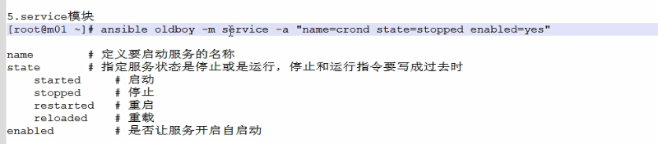



|  |
| --- |
| [root@localhost ~ 10:49:28&&48]#ansible web -m service -a "name=httpd state=started enabled=yes" |

|  |
| --- |
| [root@localhost ~ 10:49:36&&49]#ansible web -m copy -a "content='welcome to oldboy' dest=/var/www/html/index.html" |

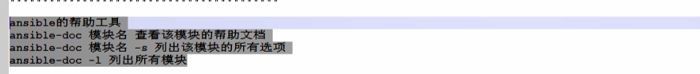

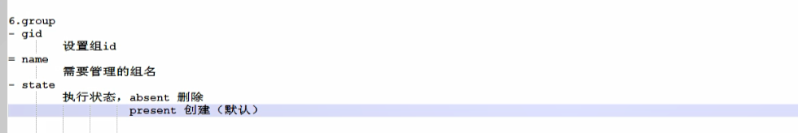

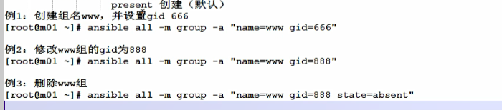

|  |
| --- |
| [root@localhost ~ 11:49:48&&10]# ansible all -m group -a "name=www gid=666"  [root@localhost ~ 11:54:09&&17]# ansible all -m shell -a "cat /etc/group|grep www" |

|  |
| --- |
| [root@localhost ~ 11:51:20&&13]#ansible all -m group -a "name=www gid=888"  [root@localhost ~ 11:54:09&&17]# ansible all -m shell -a "cat /etc/group|grep www" |

|  |
| --- |
| [root@localhost ~ 11:53:54&&16]#ansible all -m group -a "name=www gid=888 state=absent"  [root@localhost ~ 11:54:09&&17]# ansible all -m shell -a "cat /etc/group|grep www" |
|  |

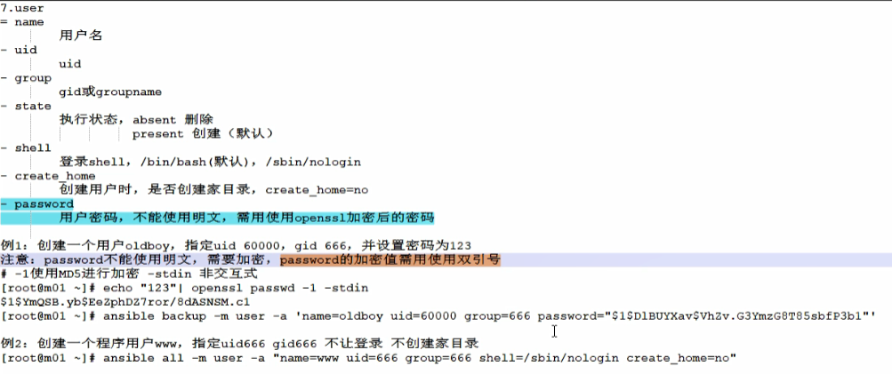

|  |
| --- |
| [root@localhost ~ 15:12:38&&4]#ansible all -m user -a "name=www uid=666 group=666 shell=/sbin/nologin create_home=no"  [root@localhost ~ 15:12:38&&4]#ansible all -m user -a "name=www uid=666 group=www shell=/sbin/nologin create_home=no" |

|  |
| --- |
| [root@localhost ~ 15:14:00&&6]#ansible backup -m user -a "name=oldboy uid=60000 group=666 password=123" |

|  |
| --- |
| [root@localhost ~ 15:32:03&&36]#echo "123" |openssl passwd -1 -stdin  $1$2B9Ro6Lc$V/Ipsvhtjru8PWNsBvWS80  [root@localhost ~ 15:32:06&&37]#ansible backup -m user -a 'name=oldboy uid=60000 group=666 password="$1$2B9Ro6Lc$V/Ipsvhtjru8PWNsBvWS80"' |

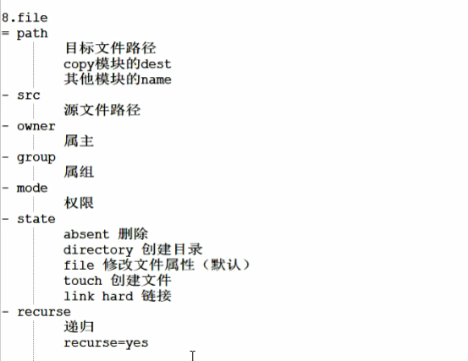

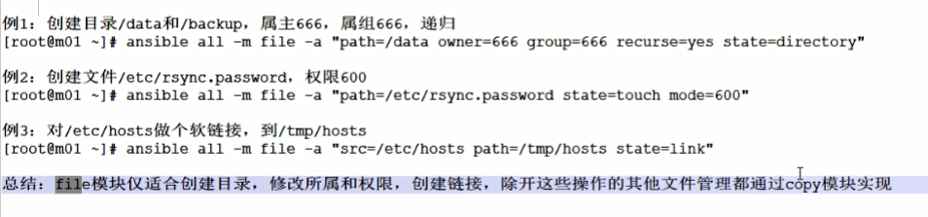

|  |
| --- |
| [root@localhost ~ 16:33:08&&4]#ansible all -m file -a "path=/data owner=666 group=666 recurse=yes state=directory" #创建    [root@localhost ~ 16:33:33&&5]#ansible all -m file -a "path=/data owner=666 group=666 state=absent" **#删除** |

|  |
| --- |
| [root@localhost ~ 22:01:06&&2]#ansible all -m file -a "path=/etc/rsync.password state=touch mode=600" |
|  |

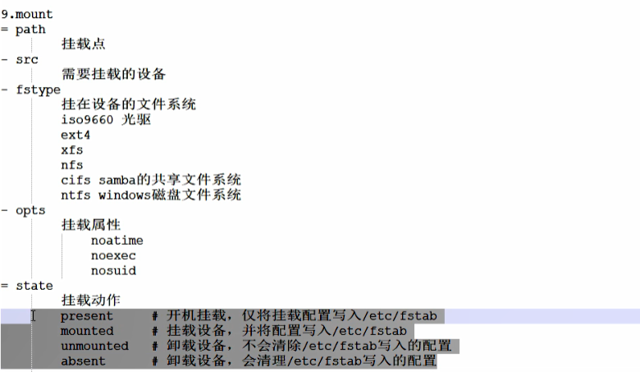

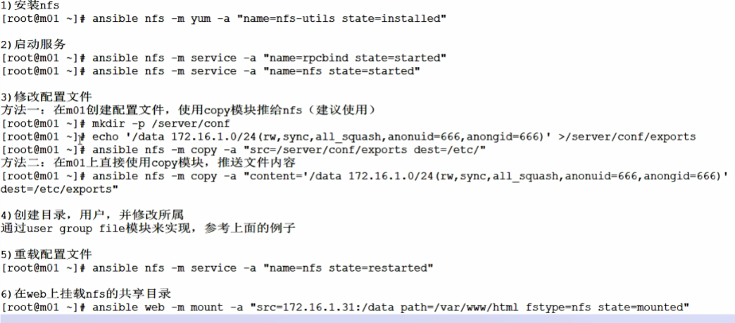

[root@localhost ~ 22:13:54&&8]#ansible nfs -m yum -a "name=nfs-utils state=installed"

|  |
| --- |
|  |

ansible nfs -m service -a "name=rpcbind state=started"

ansible nfs -m service -a "name=nfs state=started

[root@localhost ~ 15:52:10&&7]#vim /server/conf/exports

/data 192.168.91.0/24 (rw,sync,all_squash,anouid=666,anongid=666)

|  |
| --- |
| [root@localhost ~ 15:51:06&&6]#ansible nfs -m copy -a "src=/server/conf/exports dest=/etc/" |

|  |
| --- |
| [root@localhost ~ 15:53:31&&8]#ansible nfs -m copy -a "content='/data 192.168.91.0/24 (rw,sync,all_squash,anouid=666,anongid=666)' dest=/etc/exports" |
| [root@localhost ~ 15:58:18&&10]#ansible web -m yum -a "name=nfs-utils state=installed"  [root@localhost ~ 16:03:50&&16]#ansible nfs -m service -a "name=nfs state=restarted"  [root@localhost ~ 16:04:38&&17]#ansible web -m shell -a "showmount -e 192.168.91.13" |

|  |
| --- |
| [root@localhost ~ 16:05:34&&19]#ansible web -m yum -a "name=httpd state=installed" |
| [root@localhost ~ 16:07:40&&20]#ansible web -m mount -a "src=192.168.91.13:/data path=/var/www/html fstype=nfs state=present" |
| Web服务器上 |

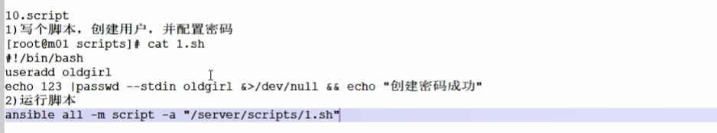



|  |
| --- |
| [root@localhost ~ 21:38:48&&19]#ansible all -m copy -a "src=/root/1.sh dest=/root/"    [root@localhost ~ 21:39:35&&22]#ansible all -m shell -a "ls /root/*.sh"    [root@localhost ~ 21:39:47&&23]#ansible all -m shell -a "crontab -l" |

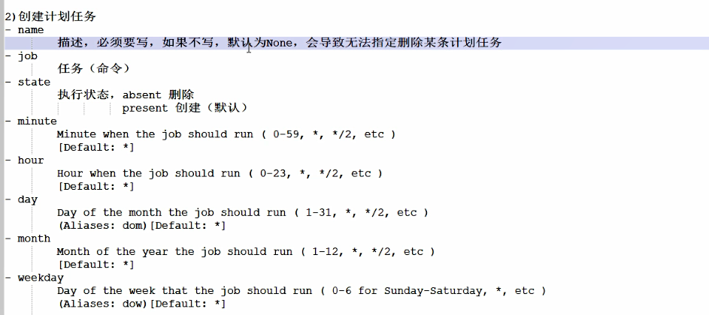

|  |
| --- |
| [root@localhost ~ 21:41:10&&24]# ansible all -m cron -a "name='1.sh' hour=1 minute=0 job='/bin/sh /root/1.sh'"    [root@localhost ~ 21:45:09&&25]#ansible all -m shell -a "crontab -l"    [root@localhost ~ 21:49:37&&35]#ansible all -m cron -a "name='2.sh' hour=2 minute=0 job='/bin/sh /root/2.sh'"    [root@localhost ~ 21:50:57&&37]#ansible all -m shell -a 'crontab -l'    [root@localhost ~ 21:51:01&&38]#ansible all -m cron -a "name='2.sh' hour=2 minute=0 job='/bin/sh /root/2.sh' state=absent" **#删除** |

**综合案例**

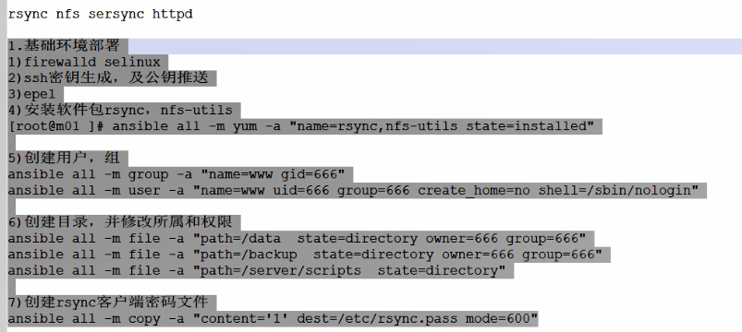

|  |
| --- |
| [root@localhost ~ 22:04:43&&5]#ansible all -m yum -a "name=rsync,nfs-utils state=installed"  [root@localhost ~ 22:05:46&&6]#ansible all -m group -a "name=www gid=666"  [root@localhost ~ 22:07:26&&7]#ansible all -m user -a "name=www uid=666 group=666 create_home=no shell=/sbin/nologin"  [root@localhost ~ 22:14:04&&16]#ansible all -m file -a "path=/data state=directory owner=666 group=666"  [root@localhost ~ 22:15:00&&17]#ansible all -m file -a "path=/backup state=directory owner=666 group=666"  [root@localhost ~ 22:15:15&&18]#ansible all -m file -a "path=/server/scripts state=directory"  [root@localhost ~ 22:15:39&&19]#ansible all -m copy -a "content='1' dest=/etc/rsync.pass mode=600" |



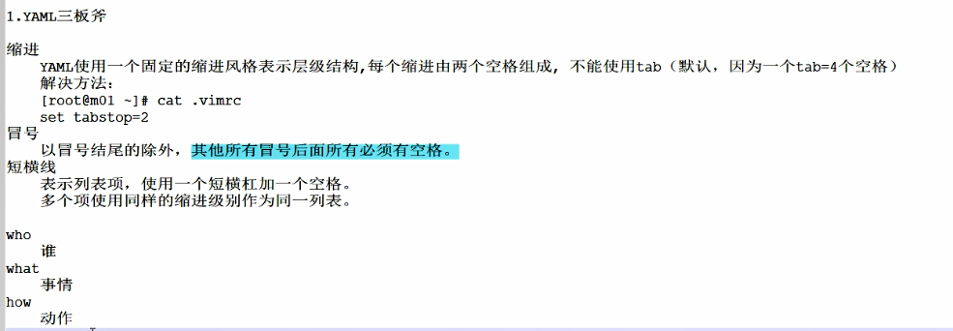



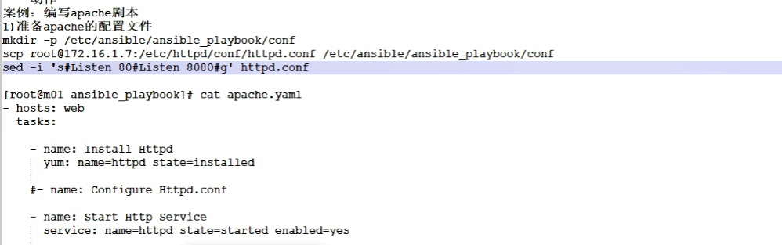

|  |
| --- |
| [root@m01 /etc/ansible/ansible_playbook 11:30:05&&18]#cat apache.yaml  - hosts: web  tasks:    - name: Install Httpd  yum: name=httpd state=installed  #- name: Configure Httpd.conf  - name: Start Http Service  service: name=httpd state=started enabled=yes  检测语法  [root@m01 /etc/ansible/ansible_playbook 11:30:04&&17]#ansible-playbook --syntax-check apache.yaml |
| 列出剧本清单  [root@m01 /etc/ansible/ansible_playbook 11:30:19&&19]#ansible-playbook --list-hosts apache.yaml    列出任务清单  [root@m01 /etc/ansible/ansible_playbook 11:32:11&&20]#ansible-playbook --list-tasks apache.yaml |

[root@m01 /etc/ansible/ansible_playbook 11:34:29&&22]#ansible-playbook -C apache.yaml

|  |
| --- |
|  |

[root@m01 /etc/ansible/ansible_playbook 11:35:18&&23]#ansible-playbook apache.yaml

|  |
| --- |
|  |

**编辑配置文件**

|  |
| --- |
| [root@m01 /etc/ansible/ansible_playbook 11:36:05&&24]#mkdir conf  [root@m01 /etc/ansible/ansible_playbook 11:37:23&&25]#cd conf/  [root@m01 /etc/ansible/ansible_playbook/conf 11:37:25&&26]#ll  total 0  [root@m01 /etc/ansible/ansible_playbook/conf 11:37:25&&27]#scp root@192.168.91.14:/etc/httpd/conf/httpd.conf ./  httpd.conf  [root@m01 /etc/ansible/ansible_playbook/conf 11:41:46&&30]#sed -i 's#Listen 80#Listen 8080#g' httpd.conf  [root@m01 /etc/ansible/ansible_playbook 11:43:08&&32]#vim apache.yaml  [root@m01 /etc/ansible/ansible_playbook 11:44:02&&33]#cat apache.yaml  - hosts: web  tasks:    - name: Install Httpd  yum: name=httpd state=installed  - name: Configure Httpd.conf  copy: src=./conf/httpd.conf dest=/etc/httpd/conf/httpd.conf  - name: Start Http Service  service: name=httpd state=started enabled=yes  [root@m01 /etc/ansible/ansible_playbook 11:45:39&&35]#ansible-playbook apache.yaml    在14上查看并没有生效。Playbook执行重复任务并不会使配置文件生效。黄色标记部分重启对配置文件不生效  需要重新编辑apache.yaml    14服务器先删除配置文件，因为之前推送过一次。再次推送配置文件还是一样，不会触发。删除模拟配置文件变更。  [root@localhost ~ 11:47:04&&4]#rm -f /etc/httpd/conf/httpd.conf      **14服务器web端口已变化。** |

**playbook综合案例**

|  |  |
| --- | --- |
| **192.169.91.11** | **ansible** |
| **192.169.91.12** | **rsync** |
| **192.169.91.13** | **Nfs,sersync** |
| **192.169.91.14** | **web** |

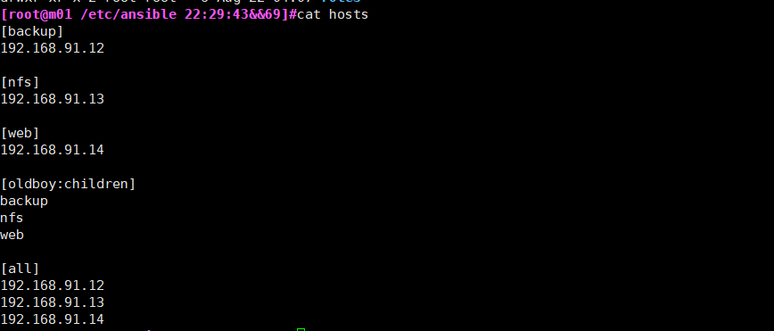

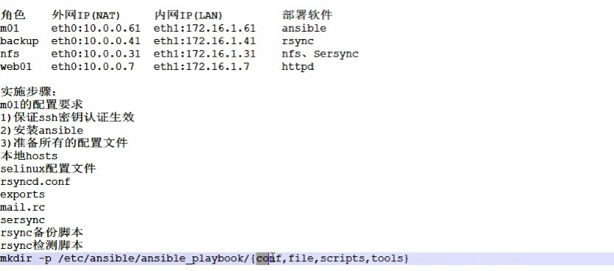

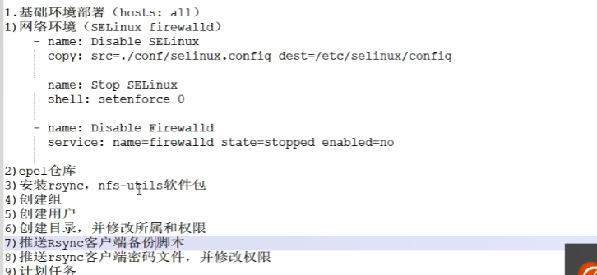

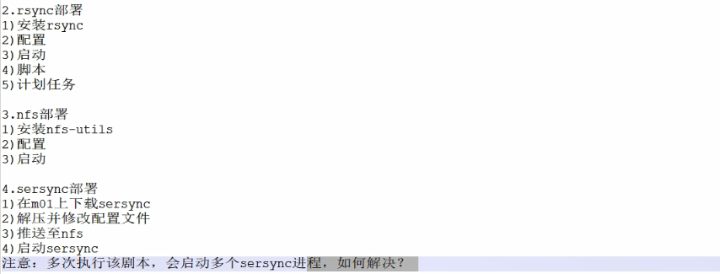

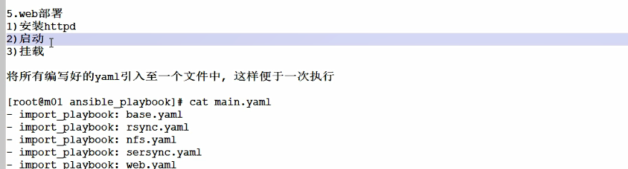

**1.资料准备**

**1.1 rsyncd.conf**

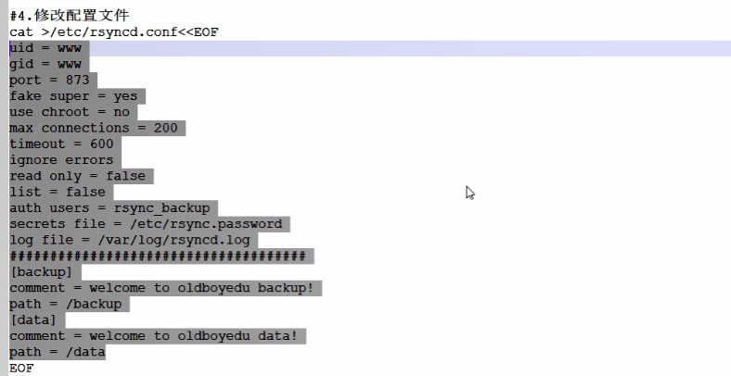

|  |
| --- |
| cat >/etc/rsyncd.conf<<EOF  uid= www  gid = www  port = 873  fake super = yes  use chroot = no  max connections = 200  timeout = 600  ignore errors  read only = false  1ist = false  auth users = rsync backup  secrets file = /etc/rsync.password  loq file = /var/log/rsyncd.log  ################################  [backup]  comment - welcome to oldboyedu backup!  path = /backup  [data]  comment = welcome to oldboyedu data!  path = /data  EOF |

在/etc/ansible/ansible_playbook/conf下

1.2 #cp /etc/selinux/config /etc/ansible/ansible_playbook/conf/selinux.config

1.3 #echo "/data 192.168.91.0/24(rw,sync,all_squash,anonuid=666,anongid=666)" > exports

1.4 #cp /etc/hosts /etc/ansible/ansible_playbook/conf/

1.5

#yum install -y mailx

#cp -a /etc/mail.rc /etc/ansible/ansible_playbook/conf/

|  |
| --- |
| cat >> mail.rc << EOF  set from=751536336@qq.com  set smtp=Smtps://smtp.qq.com:465  set smtp-auth-user=751536336@qq.com  set smtp-auth-password=lvkyiherdlmsbeca  set smtp-auth=login  set ssl-verify=ignore  set nss-config-dir=/etc/ki/nssdb/  EOF |

1. 脚本

rsync_backup.sh

|  |
| --- |
| #!/bin/bash  #1.定义变量  export PATH=/usr/local/sbin:/usr/local/bin:/usr/sbin:/usr/bin:/root/bin  Host=$(hostname)  IP=$(ifconfig ens33|awk 'NR==2{print $2}')  Date=$(date +%F)  BackupDir=/backup  Dest=${BackupDir}/${Host}_${IP}_${Date}  #2.创建备份目录  mkdir -p $Dest  #3.收集需要备份的文件  #sysconf backup  tar czf ${Dest}/sysconf.tar.gz /etc/fstab /etc/hosts /var/spool/cron/root  #logs backup  tar czf ${Dest}/log.tar.gz /var/log/messages /var/log/secure /var/log/cron  #svrconf backup  tar czf ${Dest}/svrconf.tar.gz /etc/rsyncd.conf  #4.校验  md5sum ${Dest}/* >${Dest}/back_check_$Date  #5.将备份目录推送到rsync服务端  Rsync_IP=172.16.1.12  Rsync_User=rsync_backup  Rsync_Moudle=backup  export Rsync_PASSWORD=1  rsync -avz $Dest $Rsync_User@$Rsync_IP::$Rsync_Moudle  #6.删除7天前的备份目录  find $BackupDir -type d -mtime +7 |xargs rm -rf |

rsync_check.sh

|  |
| --- |
| #!/bin/bash  #1.定义变量  Date=$(date +%F)  Path=backup  #2.校验结果  find $Path -type f -name "backup_check_${Date}"|xargs md5sum -c >${Path}/result_$Date  #3.发邮件给管理员  mail -s "Rsync backup $Date" 751536336@qq.com < ${Path}/result_$Date  #4.保留最近3天的MD5校验文件  find $Path -type f -name "*.$Date" -mtime 3 |xargs rm -f  #5.保留6个月内的备份内容  find $Path -type d -mtime +180 |xargs rm -rf |

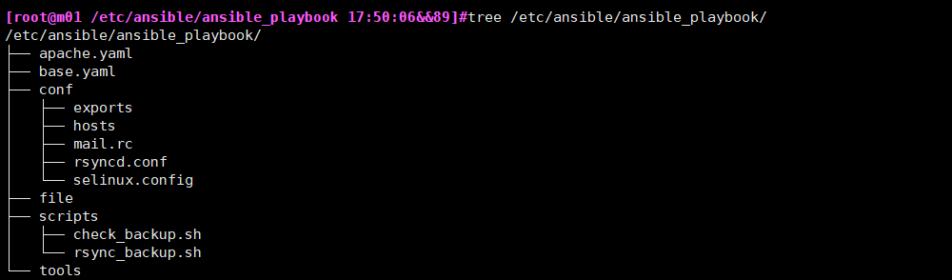

1. base.yaml

|  |
| --- |
| - hosts: all  tasks:  - name: Disable SELinux  copy: src=./conf/selinux.config dest=/etc/selinux/config  - name: Stop SELinux  shell: setenforce 0  - name: Stop Firewalld  service: name=firewalld state=stopped enabled=no  - name: Create Epel Repo  get_url: url=https://mirrors.aliyun.com/repo/epel-7.repo dest=/etc/yum.repos.d/epel.repo  - name: Install Rsync Nfs  yum: name=rsync,nfs-utils state=installed  - name: Create Group  group: name=www gid=666  - name: Create User  user: name=www uid=666 group=666 create_home=no shell=/sbin/nologin  - name: Create Directory /data  file: path=/data owner=666 group=666 recurse=yes state=directory  - name: Create Directory /backup  file: path=/backup owner=666 group=666 recurse=yes state=directory    - name: Create Scripts Directory  file: path=/server/scripts state=directory  - name: Push Rsync Backup Script  copy: src=./scripts/rsync_backup.sh dest=/server/scripts/rsync_backup.sh  - name: Push Hosts  copy: src=./conf/hosts dest=/etc/hosts  - name: Create Rsync Client Pass File  copy: content='1' dest=/etc/rsync.pass mode=600  - name: Create Rsync Clietn Backup Crontab  cron: name='Rsync Backup' hour=1 minute=0 job='/bin/sh /server/scripts/rsync_backup.sh &>/dev/null' |

1. nfs.yaml

|  |
| --- |
| - hosts: nfs  tasks:  - name: Install Nfs  yum: name=nfs-utils state=installed  - name: Push Nfs Config File  copy: src=./conf/exports dest=/etc/exports  notify: Restart NFS  - name: Start Rpcbind Service  service: name=rpcbind state=started  - name: Start NFS Service  service: name=nfs state=started  handlers:  - name: Restart NFS  service: name=nfs state=restarted |

1. rsync.yaml

|  |
| --- |
| - hosts: backup  tasks:  - name: Install Rsync Mailx  yum: name=rsync,mailx state=installed  - name: Push Rsync Config File  copy: src=./conf/rsyncd.conf dest=/etc/rsyncd.conf  - name: Create Rsync Auth File  copy: content='rsync_backup:1' dest=/etc/rsync.password mode=600  notify: Restart Rsyncd  - name: Start Rsync Service  service: name=rsyncd state=started  - name: Push Mailx Config File  copy: src=./conf/mail.rc dest=/etc/mail.rc  - name: Push Rsync Check Script  copy: src=./scripts/rsync_check.sh dest=/server/scripts/rsync_check.sh  - name: Create Rsync Check Crontab  cron: name='Rsync Check' hour=5 minute=0 job='/bin/sh /server/scripts/rsync_check.sh &>/dev/null'  handlers:  - name: Restart Rsyncd  service: name=rsyncd state=restarted |

1. sersync.yaml

|  |
| --- |
| [root@m01 /etc/ansible/ansible_playbook/tools 21:41:11&&11]# wget <https://down.whsir.com/downloads/sersync2.5.4_64bit_binary_stable_final.tar.gz>  [root@m01 /etc/ansible/ansible_playbook/tools 21:43:19&&13]#tar xf sersync2.5.4_64bit_binary_stable_final.tar.gz  [root@m01 /etc/ansible/ansible_playbook/tools 21:49:27&&21]#mv GNU-Linux-x86 sersync  [root@m01 /etc/ansible/ansible_playbook/tools 21:43:34&&15]#cdsersync  [root@m01 /etc/ansible/ansible_playbook/tools/sersync 21:43:38&&17]#vim confxml.xml |

|  |
| --- |
| - hosts: nfs  tasks:  - name: Install inotify-tools  yum: name=inotify-tools state=installed  - name: Push Sersync  copy: src=./tools/sersync dest=/usr/local/ mode=755  - name: Start Sersync  shell: /usr/local/sersync/sersync2 -dro /usr/local/sersync/confxml.xml |

1. web.yaml

|  |
| --- |
| - hosts: web  tasks:  - name: Install Httpd  yum: name=httpd state=installed  - name: Start Httpd  service: name=httpd state=started  - name: Mount NFS Store  mount: src=nfs:/data path=/var/www/html fstype=nfs state=mounted |

1. main.yaml

|  |
| --- |
| - import_playbook: base.yaml  - import_playbook: rsync.yaml  - import_playbook: nfs.yaml  - import_playbook: sersync.yaml  - import_playbook: web.yaml |

